**Watch out!**

Look out for some community health initiatives being run by The Willows in the Spring. More information will be available shortly.

**Changes**

Following a discussion at a recent patients’ group meeting with the Willows team, it has been agreed that NHS Healthcheck, flu jabs and blood tests appointments at the surgery will be made available online. This should make it simpler for patients who can access online services to make appointments. If you don’t have access to online services, you can still phone up in the usual way.

**Prescription changes**

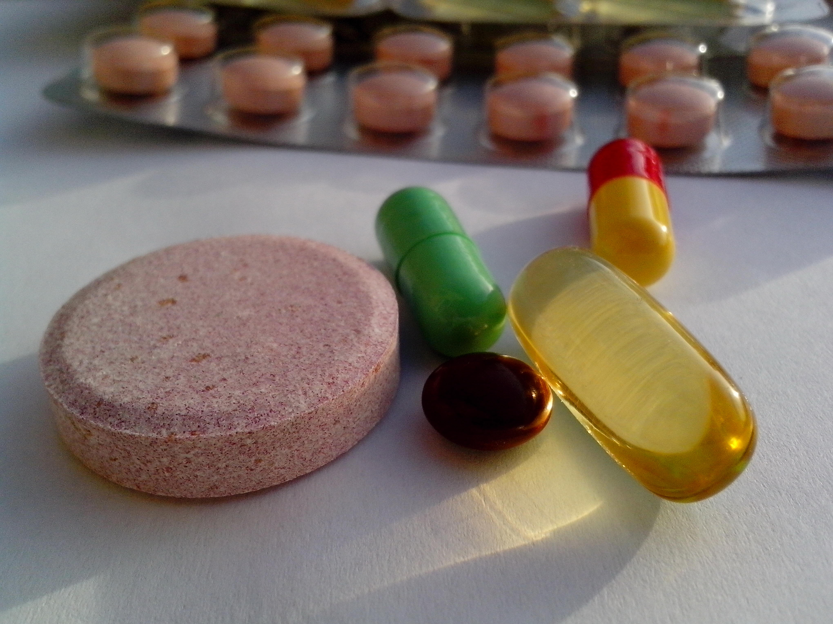The Willows has changed the process for repeat prescriptions as the way of doing things in 2023 didn’t always lead to patients getting what they needed. Some patients were just putting handwritten notes in the box outside the surgery stating their name and need for a repeat prescription. The medicine they needed wasn’t always given and sometimes either the name of the patient or even the address was missing. To make this process simpler, you can now order repeat medication in several different ways: through The Willows website; from your chosen pharmacy or using the slip attached to the prescription. Please be aware that repeat prescriptions may need you to have blood or other tests before a repeat can be issued and you may also need to see an appropriate health professional. This is to ensure that medicines are prescribed in a safe way for patients; that anything else going on in your body is picked up and to ensure that medicines are not wasted.

**Facebook Comments**

If you belong to local Facebook groups, you may read people’s requests to find a good doctors’ practice to sign up to. Often, as members of the patients’ group at The Willows, we are pleased to read comments about how well people have been treated at The Willows and how things have improved recently. Other people will comment negatively about The Willows. As a patients’ group we would be really interested to learn what you think isn’t working or why you wouldn’t recommend The Willows – these can be general views as we can’t comment on individual cases. Why not be part of the change and join the patients’ group yourself? We meet for about 1.5 hours every 3 months and we are listened to, whilst always learning more about how the practice works. Ask at reception for more details.

Here we are below after a recent meeting with some of The Willows team.

**The Willows Patient Group Newsletter**

**January 2024**

**Resolutions**

The start of a New Year often makes us think about the things that we want to do differently in our lives and common ideas are to lose weight; get fitter; give up drinking/smoking or maybe adopt a vegan or vegetarian lifestyle. Lots of those ‘resolutions’ last only a week or two as we can set ourselves such big targets that seem too hard to achieve. How about setting smaller targets that mean that you don’t have to fundamentally change your whole lifestyle? Maybe aim to lose only a pound of weight a week as after 12 months, that would amount to over 3.5 stone. Maybe think about just adding a 15 minute walk to your daily routine – 7.5 minutes out and 7.5 minutes back. If you can’t get out, how about some chair -based exercises? There are lots of options and lots of support groups if you want help. If you do make changes, don’t despair if you mess it up a little – life / holidays and ‘events’ do happen. Just start again, as a small change can amount to a significant one if you keep it up. Also maybe buddy up with someone who wants to make similar changes to their life as working together can achieve much more.

